**COURSE: Drone Technology I (Id11) *Teacher: Mrs. N. Penn* Email: pennn@gcsnc.com**

**Western Guilford High School *Phone: School (336) 316-5800 / Google Voice (336) 265-6496***

**Grading Scale**:

Process 60%

(ex: HW/Classwork/Skill Demo)

Product 40%

(ex: Projects, Assessments)

Late Policy: After 1st week, pts will be deducted in increments daily/weekly

**Tuesday Tutoring- 4:30 to 5:30 by appt.

*Assessments are usually administered on Thursdays but subject to change. Quizzes maybe unannounced.

**Course Info:** Welcome to **Drone Technology I.** This is Honor’s level course that include a credential licensing assessment as its Final Exam.

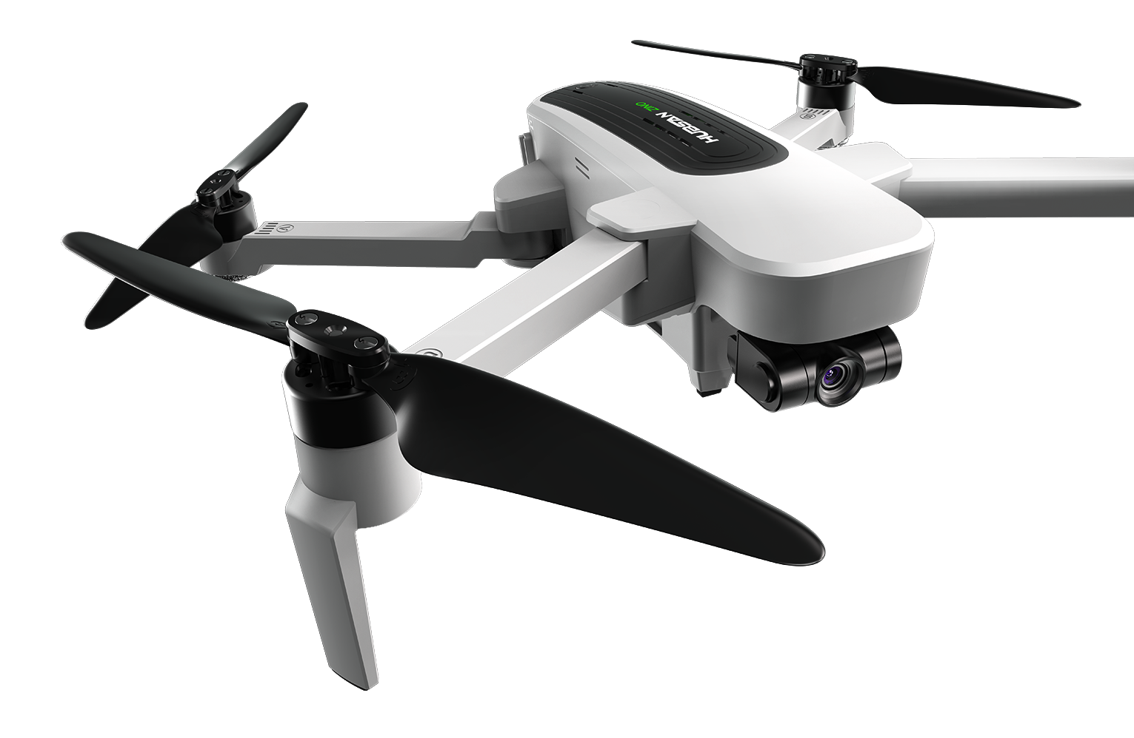

**Course Objectives**: To equip students to pass & obtain FAA Part 107A Remote (sUAS) Small Unmanned Aircraft System- Drone Pilot License and to demonstrate level of knowledge needed to safely and skillfully conduct drone flights abiding by FAA regulations.

**Course Info/ Description:** FAA 14 CFR Part 107 Test Content and Breakdown

|  |  |
| --- | --- |
| AREAS of OPERATIONS |  |
| I. Regulations | 15-25% |
| II. Airspace & Requirements | 15-25% |
| III. Weather | 11-16% |
| IV. Loading & Performance | 7-11% |
| V. Operations | 35-45% |
| Total Number of Questions | 60 |

. By March you must be 16 years old and have abasic understanding of the English language is reinforced.

m

**Expectations\***: To assist in bringing life to our goals the following guidelines for class behaviors are expected that we call “REP CPR” in our BeeHive Drone Rm…DAILY….

*Be* ***R****espectful, Be* ***E****xcellent, Be* ***P****repared,*

*Be* ***C****ompliant, Be* ***P****repared, and Be* ***R****esponsible*

**Assessment of Learning**: Students will be evaluated via Final Exam, completion of projects/flight missions, quizzes, notebook check and tests.

**Course Resource/Materials:**

***Provided***: Cost for FAA Drone Exam, Drones, Safety Equipment & more*

***Materials Needed****:* (see below)

* Notebook -spiral or composition
* *Cell Phone w/ability to download apps

*(w/data plan is a plus)* ,

* Pack of 3”x5” index cards
* Magnifying glass keep at home until FAA testing date
* *TBA/TBD: Possible Fee ($15) for AMA flight membership /insurance

**\*Electronic Communication**

*“Out of sight, Out of sound”* **No** phones/No ear buds/No electronic devices should be out during instruction or teaming unless by permission of teacher.

**Academic Policies and Procedures:**

Students will be given opportunities for tutoring and additional support as well as enrichment to support comprehension and application of instruction.

If failing class at end of quarter **students must** set up a conference time to review means for developing routine to ensure prepared to test and attain license.

*KEYS TO SUCCESS: *Examples of Ways to Ensure Expectations are Met are to*….

*Exhibit an Exemplary Attitude/Work Ethic Daily, Be Willing to Work As a Team, *Being On Time, *Be physically, mentally & emotionally Present, *Complete all Assignments & Make up Work if Absent, *Take Turns Talking, *Be Non-Confrontational, *Accept Constructive Criticism, *Stay Engaged, *Ask Questions as needed, *Practice Safety at All Times, *Ensure no electronics are used without permission – no Earbuds, No Cellphones out or in use unless with approval, *Refrain from using Profanity & **Use only Kind Words**…

**Rewards:** Extended Flight Time, Student of the Month Recognition, Drawings for Incentives, Selection/Recommendations for Special Field Trips

**Consequences:** Warning, Isolation, After-School Detention, Call Home, Referral (Note: order may vary based on incident)

***Next:*** *Sign & Return* Attached Pg. by Sept 10th

**Final Exam:** Final Exam will be the FAA ***Unmanned Aircraft General - Small (UAG)***

Student must demonstrate a level of proficiency of 70% on online/written exam to pass administered at a testing ctr at PTI.

** 85%or higher on three (3) practice exams is recommended before taking test to ensure best performance. 75% is expected.